Roots of Injustice, Seeds of Change

Toward Right Relationship with Native Peoples

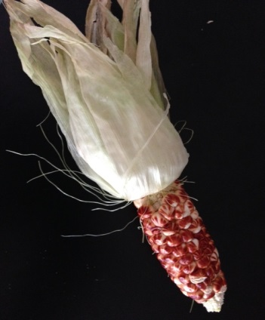

Monday, June 27, 7-9 pm

Boulder Friends Meeting
1825 Upland Ave.
Boulder CO 80304

Suggested Donation: $10-20
Please RSVP to paulaRpalmer@gmail.com
The Toward Right Relationship project offers this workshop in response to calls from Indigenous leaders at the United Nations and the World Council of Churches. The 2-hour exercise traces the historic and ongoing impacts of the Doctrine of Discovery, the 15th-century justification for European subjugation of non-Christian peoples. Our goal is to raise our level of knowledge and concern about these impacts, recognize them in ourselves and our institutions, and explore how we can begin to take actions toward “right relationship.” We provide a Resource Kit with suggestions for continued study, reflection, and action.
In the Doctrine of Discovery, we find the roots of injustice. In the U.N. Declaration on the Rights of Indigenous Peoples, we find the seeds of change. How can we nurture these seeds to bring forth the fruits of right relationship among all peoples?
“This workshop is an innovative and impactful step towards healing. Working with the truth that has never been told about the American myth is vital to all of us in our country if we are to move forward in a more healthy way. ” -- Brett Shelton (Oglala Sioux Tribe), Attorney, Native American Rights Fund
“Like everyone else I ask, I did not know about the Doctrine of Discovery. The [workshop] was an amazing experience that I expect to remember till my dying day. The mix of clear statements, together with the experiential learning, sent those lessons deep into my understanding.” --Jim Grant, Acadiana Friends Meeting, Louisiana
"This program brought up emotions that I haven’t let myself feel for a while. Now I am ready for action and my mind is spinning with ideas.” --Nico Larson, Naropa University
For more information, please contact project director, Paula Palmer, at paulaRpalmer@gmail.com. Visit boulderfriendsmeeting.org/ipc-right-relationship
Toward Right Relationship Workshop Presenters

Paula Palmer is a sociologist, writer, and activist for human rights, social justice, and environmental protection. In collaboration with Native American advisors, she created the Toward Right Relationship workshops titled, “Roots of Injustice, Seeds of Change: Toward Right Relationship with America’s Native Peoples” (for adults) and “Re-Discovering America: Understanding Colonization” (for middle schools and high schools).

As executive director of the non-profit organization, Global Response, Paula directed over 70 international campaigns to help Indigenous peoples defend their rights and prevent environmental destruction. In Costa Rica, where she lived for 20 years, she published five books of oral history in collaboration with Afro-Caribbean and Bribri Indigenous peoples.

From 1995 to 2001, Paula served as editor for health and environment of Winds of Change magazine, a publication of the American Indian Science and Engineering Society (AISES). She holds an M.A. degree in sociology from Michigan State University. She is profiled in American Environmental Leaders From Colonial Times to the Present (ABC-CLIO, 2000).

Paula is a recipient of the Elise Boulding Peacemaker of the Year Award (given by the Rocky Mountain Peace and Justice Center), the Jack Gore Memorial Peace Award (given by the American Friends Service Committee), the International Human Rights Award (given by the United Nations Association of Boulder County), and the Multicultural Award, in the “Partners” category, given by Boulder County’s Community Action Programs.

Contact Paula at paulaRpalmer@gmailcom

Jerilyn DeCoteau is a member of the Turtle Mountain Band of Chippewa Indians in North Dakota. She received her law degree from the University of Oregon. As a lawyer, she has pressed for the rights of Indian tribes to govern themselves, control their resources and insure human rights for their members. She practiced Indian law at the Native American Rights Fund, U.S. Department of Justice, and for her Tribe. She was Director of the Indian Law Clinic at the University of Colorado, and has taught Indian law courses at Yale Law School, the University of Denver law school, and at the Turtle Mountain Community College. She is currently Chief Justice for the Pueblo of San Ildefonso Supreme Court, a judge on the Turtle Mountain Tribal Appeals Court, and she does consulting on issues of tribal governance and capacity building.

Jerilyn has been active on several community and Indian boards. She is currently active in Reading to End Racism and the Toward Right Relationship Project, and is president of the Board for the National Native American Boarding School Healing Coalition. In 2002 she received the Multicultural Award for Government, awarded by Boulder County Community Action Programs.

Contact Jerilyn at decoteau_jerilyn@hotmail.com

