Boulder Friends Meeting
Indigenous Peoples Concerns Committee

Dear Friends,

Please join us for a screening of the award-winning documentary film, “Two Rivers.”
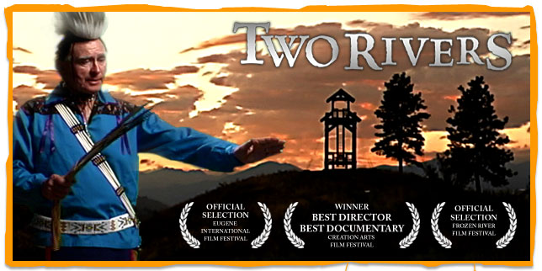
Sunday, January 15, 2017

3 – 4 pm: Film
4 – 5:30 pm: Discussion
Boulder Friends Meeting
1825 Upland Ave, Boulder 80304

Donations cheerfully accepted

“Two Rivers” is a moving story of reconciliation and healing between Native and non-Native peoples in a rural Washington community. It starts with a few tentative conversations over coffee, and it deepens as the participants hear each other’s stories. Something quite wonderful emerges.

Is there a need for such a dialogue in Boulder County? What would it look like? Let’s talk about it.

For more information, please contact Paula Palmer, paulaRpalmer@gmail.com

